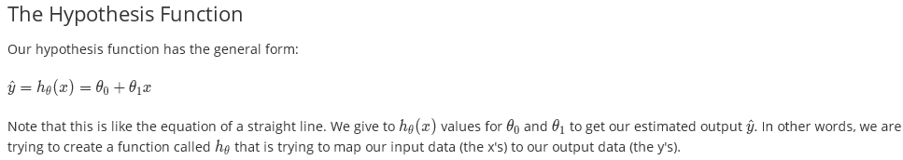

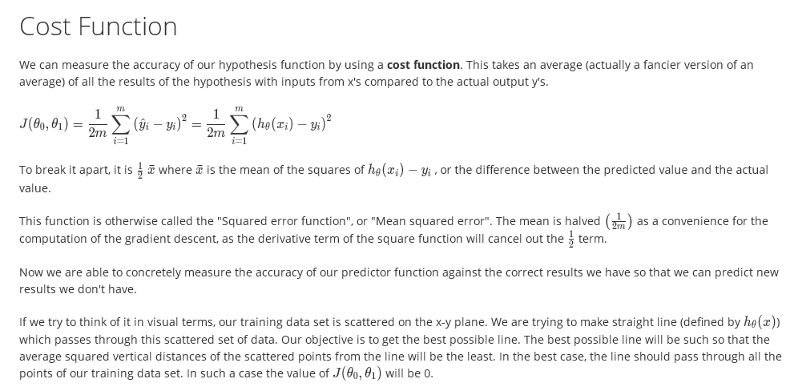

ML:Gradient Descent

So we have our hypothesis function and we have a way of measuring how well it fits into the data. Now we need to estimate the parameters in hypothesis function. That's where gradient descent comes in.

Imagine that we graph our hypothesis function based on its fields Theta_0 and theta_1 (actually we are graphing the cost function as a function of the parameter estimates). This can be kind of confusing; we are moving up to a higher level of abstraction. We are not graphing x and y itself, but the parameter range of our hypothesis function and the cost resulting from selecting particular set of parameters.

We put theta_0 on the x axis and theta_1​ on the y axis, with the cost function on the vertical z axis. The points on our graph will be the result of the cost function using our hypothesis with those specific theta parameters.

We will know that we have succeeded when our cost function is at the very bottom of the pits in our graph, i.e. when its value is the minimum.

The way we do this is by taking the derivative (the tangential line to a function) of our cost function. The slope of the tangent is the derivative at that point and it will give us a direction to move towards. We make steps down the cost function in the direction with the steepest descent, and the size of each step is determined by the parameter α, which is called the learning rate.

The gradient descent algorithm is:

repeat until convergence: { }

where

j=0,1 represents the feature index number.

Intuitively, this could be thought of as:

repeat until convergence:



